Assessing the statistical properties of 'growing seasons' by fitting parametric models to remote sensing time series

Michel M. Verstraete
European Commission, DG-Joint Research Centre
Institute for Environment and Sustainability
29 February 2008

1 Introduction

Vegetation type is intimately related to climatic conditions, soil properties and water availability (e.g., Woodward, 1987). The spatial distribution and temporal evolution (phenology) of plant properties are largely driven by the dynamics of weather and climate (e.g., Monteith, 1975), and the canopy cover, in turn, influences the climate itself by partially controlling the balances of radiation, heat, water, carbon and other biogeochemicals at and near the land surface (e.g., Bolin et al., 1979; Monteith and Unsworth, 1990). Monitoring vegetation is economically and scientifically important, in particular to keep track of agricultural productivity.

2 Objectives

The purpose of this report is to review and describe mathematical procedures that can be implemented to document the state and evolution of the terrestrial plant cover, and especially to characterize the statistical properties of 'growing seasons', on the basis of remote sensing observations from space.

In this document, the expression 'growing season (GS)' refers to the period of active growth, development and senescence of terrestrial vegetation. The concept makes sense only for those ecosystems and environments that are subject to seasonal variability, and each such 'growing season' is deemed to include both a 'growth phase' and a 'decay phase'.

Two different problems should be distinguished from the outset: describing the historical evolution of the properties of vegetation as they can be retrieved from existing records (i.e., for already completed seasons), and operationally monitoring on-going changes, including detecting or even predicting events as they unfold, in near real time. This report only considers the first problem, though the methods described below may be extended in the future to address the latter.

A large number of vegetation properties can be monitored to characterize the phenology of the canopy. Some of these can be estimated from space measurements, including the fractional ground cover, Leaf Area Index (LAI), biomass, the chlorophyll content of the leaves, the Fraction of Absorbed Photosynthetically Active Radiation (FAPAR), etc. In this report, canopy phenology will be characterized by the following statistical measures derived from remote sensing observations of anyone of these variables of interest:
- The date of the start of the growth phase
- The date of the end of the decay (senescence) phase
- The length of the period of activity
- The minimum value of the variable of interest prior to and/or after the end of the GS
- The maximum value of the variable of interest during the GS
- The timing of the maximum value of the variable of interest
- The maximum rate of growth during the growth phase
- The timing of this maximum growth rate
- The maximum decay rate during the decay phase
- The timing of this maximum decay rate
- The integrated value of the variable of interest over the growing season

In the case of FAPAR, the accumulated value throughout the GS has been shown to be closely related to the yield or biomass production during that period.

3 Data sources

Remote sensing techniques have long been exploited to document the spatial distribution and temporal evolution of vegetation. Whether based on a traditional vegetation index, such as the Normalized Difference Vegetation Index (NDVI) or more relevant and accurate biogeophysical properties such as the Fraction of Absorbed Photosynthetically Active Radiation (FAPAR), Space Agencies and Data Providers (e.g., NASA, ESA, EC/JRC) can be expected to deliver time series of biogeophysical variables and indicators that are directly or indirectly related to vegetation properties. This report does not discuss the respective merits of alternative input data sources or types. The remainder of this document focuses on the statistical analysis of an arbitrary time series for one such biogeophysical variable of interest, presumably exhibiting seasonal variability.

Actual remote sensing records for a given location often contain missing values. These may occur because of temporary instrument unavailability (calibration sequence, platform issues, etc) or, more frequently, because of the impossibility to derive a reliable estimate of the geophysical variable due to cloud obscuration, lack of light, etc. In the following discussion, the time series will be assumed to include values of the biogeophysical variable of interest for all possible time values of a pre-defined observation schedule, although some of these values may be coded to represent missing value. Valid (i.e., meaningful) values are defined as belonging to a specified interval; all values outside that interval will be considered as missing.

The methods and algorithms described for a single time series can be applied repetitively for a set of neighbouring locations, and the results can be mapped to provide a comprehensive geographical coverage.

4 Modelling approach

Modelling vegetation growth and development has been extensively studied and described in the literature (e.g., Charles-Edwards et al., 1986). Many models attempt to predict the occurrence of specific stages of development or the yield of crops on the basis of specific physiological variables and processes, such as radiation, temperature and water availability, photosynthesis, plant type, etc. This report only considers mathematical models suitable for the description of the overall phenological cycle, without regards for the possible physical, chemical or biological causes or implications of these events. The goal is only to describe the time evolution of the observed remote sensing signals, not to explain how plants grow and senesce.

It is conceivable to apply standard statistical methods to the observed time series directly, but fitting a mathematical model to these time series prior to the statistical analysis offers multiple advantages:
- Time series of land surface properties derived from remote sensing may not be continuous or complete, for instance because observations of land surfaces in the solar spectral domain are not possible in the presence of clouds, or when the intensity of the incoming solar light is too low (as occurs at high latitudes outside of the summer season). The assessment of events such as the start (or the peak) of a GS may thus be biased if one relies directly on the measurements.
- Measurements are always subject to uncertainties, both systematic and random, which result from a wide range of processes, so that individual records cannot be taken at face value. Fitting a mathematical model to the observational data permits us to objectively describe the variability of the canopy while taking into account the known or expected accuracy of the measurements.
- It is desirable to apply objective criteria to define the statistical characteristics of a seasonal time series. Defining and computing these characteristics on the basis of a smooth and continuous model is easier to implement, more precise and more stable (less sensitive to the timing of individual measurements) than an approach based directly on the raw observations.

For these reasons, a parametric model is first adjusted to the available data, and the phenology of the canopy is then derived from a statistical analysis of that model.

4.1 Model selection

The parametric model to be adjusted to the data should meet the following criteria:
- Be representative of typical seasonal signals, possibly allowing for multiple growth and decay phases per year (e.g., double cropping).
- Be applicable everywhere and all the time (independence from latitude, longitude, altitude, time, hemisphere, type of plant canopy or ecosystem, managed or unmanaged environment, etc).
- Be insensitive to the presence and temporal distribution of missing data due to instrument malfunctions, calibration errors, cloud coverage, etc.
- Require the smallest possible set of parameters, to ease the fitting (inversion) procedure and ensure that the retrieved parameters values are reliable.
- Be mathematically simple, continuous, derivable, and computationally cheap to evaluate.
- Yield reliable and accurate information that is of direct relevance and value to the user or downstream application.

Plant phenology typically exhibits seasonality, with recurring patterns from year to year. Fourier analysis can be used to analyze such time series, but such a global approach may often require using a large number of components (terms) because the timing and intensity of events may be quite variable from year to year. In the context of this study, it may be more relevant and appropriate to derive the intrinsic (local) characteristics of successive GS, each considered individually.

Many biochemical, physiological and ecological processes exhibit a typical 'S-shaped' behaviour, which has been described with functions such as the logistic curve, the sigmoid, etc. It is thus natural to construct a phenological model as a sum or superposition of two such functions, one to describe the growth phase and the other to represent the decay phase.

4.2 Model formulation

A number of functions exhibit (or can be forced to take on) an 'S-shape'. The model proposed here to simulate a single GS is the Parametric Double Hyperbolic Tangent (PDHT) model, given by

where the 7 parameters play the following roles:
- a₀ provides an overall minimum (base) value
- a₁ and a₄ define the amplitudes of the growth and decay phases, from the base to the maximum and from the maximum to the final value, respectively
- a₂ and a₅ allow shifting the inflexion points of the growth and decay phases along the time axis, and
- a₃ and a₆ define the slopes of the growth and decay phases, respectively.

Figure 1 shows the trace of this function for the indicated values of the model parameters.

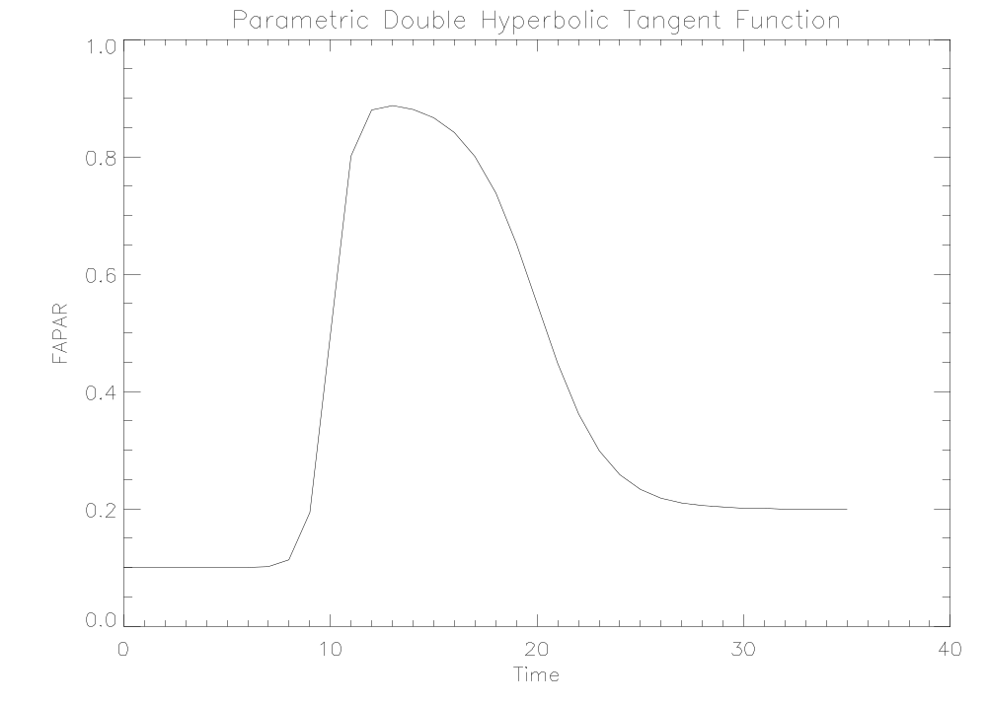
Figure 1: Graph of the Parametric Double Hyperbolic Tangent function when a₀=0.1, a₁=0.8, a₂=10.0, a₃=1.0, a₄=0.7, a₅=20.0 and a₆=-0.3. The time axis is expressed in units of 10 days. The vertical axis is scaled for a vegetation property varying between 0 and 1, such as FAPAR.

4.3 Model fitting

Standard mathematical procedures exist to adjust this (or indeed an arbitrary) parametric model to a time series fragment containing a single seasonal peak. Experience has shown that the IDL procedure CURVEFIT works satisfactorily for this purpose. Alternative algorithms usable in codes written in different languages can be found in Press et al., 1992, or similar sources.

The efficiency of the fitting (inversion) procedure can often be increased when the derivative of the model with respect to its parameters can be computed analytically; hence preference should be given to models that are continuously derivable. Some of these procedures allow for the specification of error bars or uncertainties on the available measurements, in which case it may be possible to provide error bars or uncertainties on the retrieved parameters.

Fitting (inversion) procedures usually require initial values for the model parameters: these provide a starting point from which to search for an optimal solution. This step should be performed with great care because the fitting procedure may not converge, or yield unrealistic parameter values, if the initial values are too far from the 'true' values.

The 7 parameters of the PDHT model are initialized as follows: If m(t) designates the (valid) observed value of the time series at time t,

- a₀ = m(t₀), where t₀ designates the date of the first valid measurement in the period considered.
- a₁ = 2.0 [m(t_{max}) - m(t₀)], where t_{max} designates the timing of the maximum (peak) observed value reached within the period considered.
- a₂ = (t₀ + t_{max}) / 2.0.
- a₃ = 0.5.
- a₄ = 2.0 [m(t_{max}) - m(t_{N})], where t_{N} designates the date of the last valid measurement in the period considered.
- a₅ = (t_{max}+ t_{N}) / 2.0.
- a₆ = -0.5.

4.4 Quality of the model fit

A key piece of information resulting from the fitting procedure is an estimate of the quality of the fit. This can be expressed as a root mean square (RMS) difference between the valid observations and the model, or some other appropriate measure. Model parameter values may have to be discarded, or at least treated with particular care, if this quality indicator is not good enough (e.g., RMS too high). In some cases, an acceptable but less than perfect fit quality should prompt a more detailed inspection of the input data.

5 Derivation and exploitation of the results

5.1 Estimating growing season characteristics

The statistical characteristics of a GS can be objectively calculated as follows, once the parametric model has been adjusted to the variable of interest:

5.1.1 The maximum (peak) value for the given growing season

The maximum estimate corresponds to an actual measurement, so the value may be biased (generally too low) if there are missing values in the time series at or near this peak. This estimate includes any actual error associated with that particular measurement, in which case it can be either too low or too high by an amount given by the declared range of accuracy of the product. There may be two or more identical maximal values defining a period of high values at the height of the season, and it is conceivable that these may not be consecutive.

5.1.2 The timing of the maximum (peak) value for the given growing season

If there are missing values at or near the actual maximum, the timing of the observed maximum will of course reflect the date when valid observations were made, and none of these may correspond to the date of the actual maximum, had the system been observable and observed on a continuous basis. There may also be ambiguity about the timing of the maximum if the time series includes two or more identical values, in which case it may be necessary to adopt a systematic rule, for instance to always select the first occurrence as the most representative, or to assign its timing to the middle of the corresponding period (in this latter case, the timing may or may not be part of the observational sampling scheme).

5.1.3 The timing of the start of the growth phase

The growth phase is deemed to start whenever the value of the modelled time series exceeds a threshold defined as the initial base value a₀ (asymptotic model value well before the start of the growth phase) plus 5% of the amplitude a₁.

5.1.4 The timing of the end of the decay phase

The decay phase is deemed to end whenever the value of the modelled time series drops below a threshold defined as the final base value a₀+a₁-a₄ (asymptotic model value well after the end of the decay phase) plus 5% of the amplitude a₄.

5.1.5 The length of the period of plant activity

The length of the growing season is clearly dependent on and associated with the particular set of start/end criteria used. This is simply the time period between the start of the growth phase and the end of the decay phase:

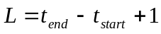

in the appropriate units of time.

Notes on the start, end and length of the period of activity:
- Some of the better time compositing algorithms report the variable of interest closest to the average during the specified period as the most representative of that period. In this case, the exact timing of these particular observations is also known, and the length can be given with a higher precision than the time unit of the 'composited' time series.
- Different criteria can be used to define these start and end events. Some authors have defined the start (end) of the growing season as the time when the signal of interest exceeds (drops below) half of the total amplitude. Others have used crop-specific definitions; in this case, the practical application of such a rule would have to rely on a separate mechanism to detect the areas covered by these crops. Also, this approach does not yield results when the vegetation type is not explicitly foreseen and recognized. More generally, it is conceivable to simultaneously define a number of start and end events (like quartiles or percentiles in statistics), and let the user assess which one best meets his or her needs.

5.1.6 The maximum rate of growth (positive slope) during the growth phase

This value is provided directly as one of the model parameters (a₃); no further computations are needed to estimate this statistics.

5.1.7 The timing of the maximum rate of growth

This value is obtained as part of the model inversion procedure; it is parameter a₂. Mathematically, this is also the timing of the inflexion point during the growth phase.

5.1.8 The maximum rate of decay (negative slope) during the decay phase

Similarly, this value is retrieved as model parameter (a₆) during the model fitting procedure.

5.1.9 The timing of the maximum rate of decay

Again, this value is obtained as part of the model inversion procedure; it is parameter a₅. Mathematically, this is also the timing of the inflexion point during the decay phase.

5.1.10 The cumulative value of the time series during the period of plant activity

When the input time series reports on a biophysical variable such as FAPAR, this cumulated value is expected to be related to the total biomass production (or yield) of the observed vegetation canopy. It can be estimated either on the basis of the original data, supplemented by simulated values whenever there are missing values, or from the model itself. The latter estimate should be less sensitive to outliers and more stable with respect to the presence and temporal distribution of missing values.

In some applications, partial (or successive) cumulative values may have some specific interest or benefit. For instance the cumulative value from the start of the growth phase until the maximum is reached (or, more generally the cumulative value from the start of the growth phase to the most current available value) may be an early indicator of the total production (yield).

5.2 Estimating missing values

Once the model has been fitted to the data for a particular GS and the fit is deemed of sufficient quality, missing values can be evaluated on the basis of the model, if that is useful for the application at hand. This results in a series where most of the data elements are actual observations, and where missing values in the original series are replaced by estimated values.

More generally, a realistic, complete and smooth time series representing the growing season for that particular location and for a specified season can be generated for any arbitrary sampling in time, independently from the original observational sampling. In this case, all time series elements are simulated, and the resulting series is very smooth: it corresponds to a particular sampling of an analytical formula.

6 Implementation issues

6.1 Pre-processing

In an operational context, it is very useful to screen out a priori those time series that should not be analyzed further, or should be treated separately. Such special cases include time series that
- do not exhibit significant seasonality
- contain too many missing values to allow a meaningful analysis
- are so noisy that growth and decay phases are unlikely to be detectable with any reliability
- are dominated by one or more events or non periodic processes (such as a fire)

Eliminating these cases, or treating them with dedicated algorithms, may simplify or accelerate the processing of other cases, or avoid generating unreliable results.

The input to the model fitting procedure described earlier is expected to be a time series fragment that contains a single growth and decay sequence. This presupposes the existence of a mechanism to isolate these successive periods, but that becomes a circular argument, as it is precisely the purpose of the algorithm itself to isolate and characterize these growing seasons. It is thus necessary to bootstrap the process, and this is the second purpose of the pre-processing stage. Both issues are addressed by acquiring and analyzing statistics on the entire input time series.

6.1.1 Non-parametric statistics

Valid values in the time series are first counted, and processing may stop if the number of valid observations is not sufficient, or, equivalently, if there are too many missing values (e.g., more than 40% of the time series). Care should be taken not to eliminate time series where growing seasons are clearly defined whenever data are available, and missing values only reflect the lack of solar light during the winter season, as may occur at high latitudes.

The absolute minimum, the absolute maximum as well as the 5th, 25th, 50th, 75th and 95th percentiles (noted p_{x}) of the entire time series of valid values are computed. The time series is deemed not to contain reliable evidence about a seasonal signal it the difference p₉₅-p₀₅ is not at least as large as 1.5 times the declared accuracy of the measurements. For instance, if the advertised accuracy of individual observations in the time series is 0.1, then the p₉₅-p₀₅ should be larger than 0.15.

6.1.2 Smoothed time series

It may be useful to smooth the original time series, especially if the intrinsic variability is relatively large, or exhibit appreciable noise, or contains a relatively large number of missing values. In those cases, the shape of the autocorrelation function (described next) for the original time series might lead to misinterpretations, while the autocorrelation of the smoothed time series may be more reliable. The smoothing should be implemented with an appropriate moving average filter, taking care not to introduce spurious frequencies in the resulting time series (equal weights should be avoided) and accounting for the presence of missing values. This smoothed time series is only used as a guide to further processing, not for deriving results.

6.1.3 Autocorrelation function

The autocorrelation function is evaluated for both the original and the smoothed (complete) time series, for all meaningful lags up to about 1.5 year.
- If it exhibits only a single maximum (at lag 0) and is monotonically decreasing, the original time series does not contain any significant periodicity (seasonality), and no further analysis is required.
- If it exhibits two peaks, typically at lags 0 and around one year (in whatever time units are used in the time series: 12 months, 36 periods of 10 days, 365 days, etc), the time series can be assumed to contain primarily a seasonal pattern with one GS per year.
- If it exhibits three local maxima, typically at lags 0, 6 months and 1 year, the corresponding time series likely concerns an area characterized by two GS per year.

Estimating the autocorrelation for a time series that includes missing values poses its own challenges, as the correlation at any given lag may contain fewer than the nominal number of pairs of valid observations. Since the use of this function here is only to detect the number of local maxima in the function, it is sufficient to estimate those individual values on the basis of available pairs only. It is possible that the autocorrelation may not be computed at some lags, if the number of pairs of valid values at that lag is insufficient.

The autocorrelation of the smoothed time series may be useful if its shape exhibits fewer peaks than the autocorrelation of the original time series, as this may indicate either a noisy signal or a series that includes many missing values.

References

Bolin, B., E. T. Degens, S. Kempe and P. Ketner (Editors) (1979) The Global Carbon Cycle, SCOPE 13, John Wiley, 491 pp., ISBN 0-471-99710-2.

Charles-Edwards, D. A., D. Doley and G. M. Rimmington (1986) Modelling Plant Growth and Development, Academic Press, 235 pp., ISBN 0-12-169362-7.

Monteith, J. L. (Editor) (1975) Vegetation and the Atmosphere, Academic Press, 278 pp., ISBN 0-12-505101-8.

Monteith, J. L. and M. H. Unsworth (1990) Principles of Environmental Physics, Edward Arnold, 291 pp., ISBN 0-7131-2931-X.

Press, W. H., A. A. Teukolsky, W. T. Vetterling and B. P. Flannery (1992) Numerical Recipes in FORTRAN, Second Edition, Cambridge University Press, 963 pp, ISBN 0-521-43064-X.

Woodward, F. I. (1987) Climate and Plant Distribution, Cambridge University Press, 174 pp., ISBN 0-521-28214-4.

